**SSL Certificate Renewal Steps**

**Step 1:** Run below command for update .pem files

sudo certbot renew --standalone --agree-tos --preferred-challenges http --force-renewal

**Steps 2 :** open teminal and go to PATH:// **etc/letsencrypt/live/rockpigeon-chevron.sigmastream.com**

And check here .pem file are upadte with latest date

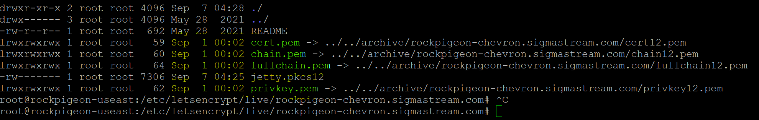

**Strep 3:** Generate Jetty.PKcs12 File Using below command

**Openssl pkcs12 -export -in fullchain.pem -inkey privkey.pem -certfile cert.pem -name ${domain} -out jetty.pkcs12**

Note: when you run this command then its ask password put this password “**Sigmastream#1**”

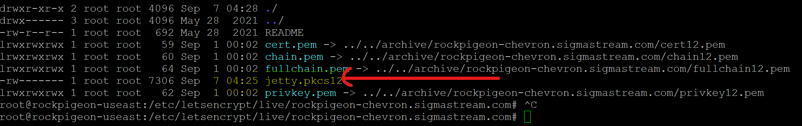

Step 4: Now Generate .jks file (Keystore) using the .pks12 file.

**keytool -importkeystore -noprompt -srckeystore jetty.pkcs12 -srcstoretype PKCS12 -srcstorepass "SigmaStream#1" -destkeystore keystore**

Note: when you run this command then its ask password put this password “**Sigmastream#1**”

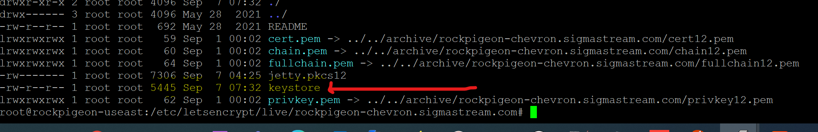

Step 4 : Now Stop Server and rename existing keystore file and place new keystor file here which loacted on **PATH://sigmastream/rockpigeon/server/jettyhome/etc/**

**Stop server** : sudo service rockpigeon stop

**For copy keystore file** : sudo cp keystore /sigmastream/rockpigeon/server/jettyhome/etc/

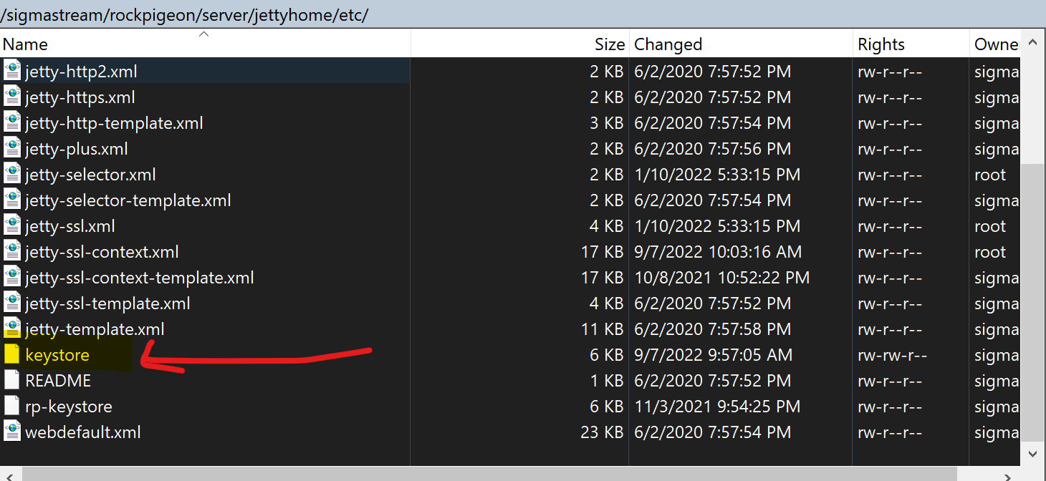

**Step 5**: Start Server

sudo service rockpigeon start

**Step 6:** Now open URL and click on lock symbol. For confirmation our certificate is renew or not.

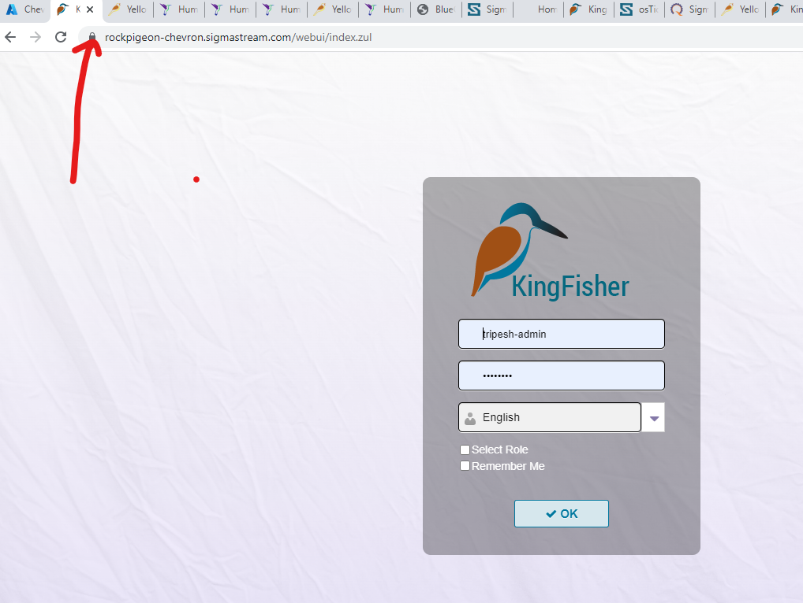

Click on connection Secure

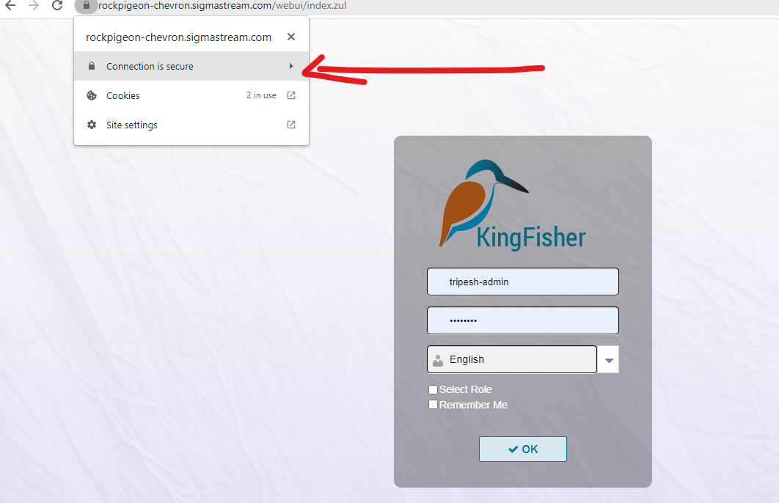

Click on certificate valid

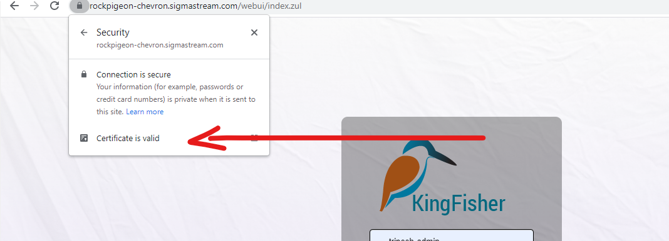

Now here you can check SSL Certificate Expire date and Issue date.

